Chapter 9, Problem 66.

For the circuit in Fig. 9.73, calculate Z_{T} and V_{ab}.

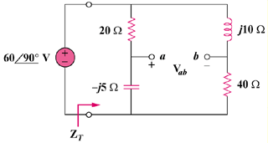

Figure 9.73
For Prob. 9.66.

